# YARC Branding Guide

Updated January 2019

# Typography

Heading 1: Roboto Slab 28pt Bold

## Heading 2: Roboto Slab 24pt Normal

### Heading 3: Roboto 20pt Medium

#### Heading *4: Roboto 18pt Medium Italic*

##### Heading 5: Roboto 16pt Normal

###### Heading 6: Roboto 15pt Normal Italic

Body text: Roboto 12pt Normal

Serif: EB Garamond 13pt Normal

# Colors

Use these colors whenever possible.

|  |  |  |
| --- | --- | --- |
| Primary #451EA6  RGB: 69, 30, 166  CMYK: 58, 82, 0, 35 | Light Primary #7415E3  RGB: 116, 21, 227  CMYK: 49, 91, 0, 11 | Secondary #3D69DE  RGB: 61, 105, 222  CMYK: 73, 53, 0, 13 |
| Accent 1 #32B1EE  RGB: 50, 200, 255  CMYK: 80, 22, 0, 0 | Accent 2 #B5070A  RGB: 181, 7, 10  CMYK: 0, 96, 94, 29 | Accent 3 #3CB78F  RGB: 155, 240, 176  CMYK: 35, 0, 27, 6 |
| White #F2F2F2  RGB: 242, 242, 242  CMYK: 0, 0, 0, 0 | Grey #737373  RGB: 115, 115, 115  CMYK: 0, 0, 0, 55 | Black #121212  RGB: 18, 18, 18  CMYK: 0, 0, 0, 100 |

# 

# Logos

Vector versions of these logos are available at <https://yarc.world/logos>.

### Large

Use this when the “WY4RC” is large enough to easily read.

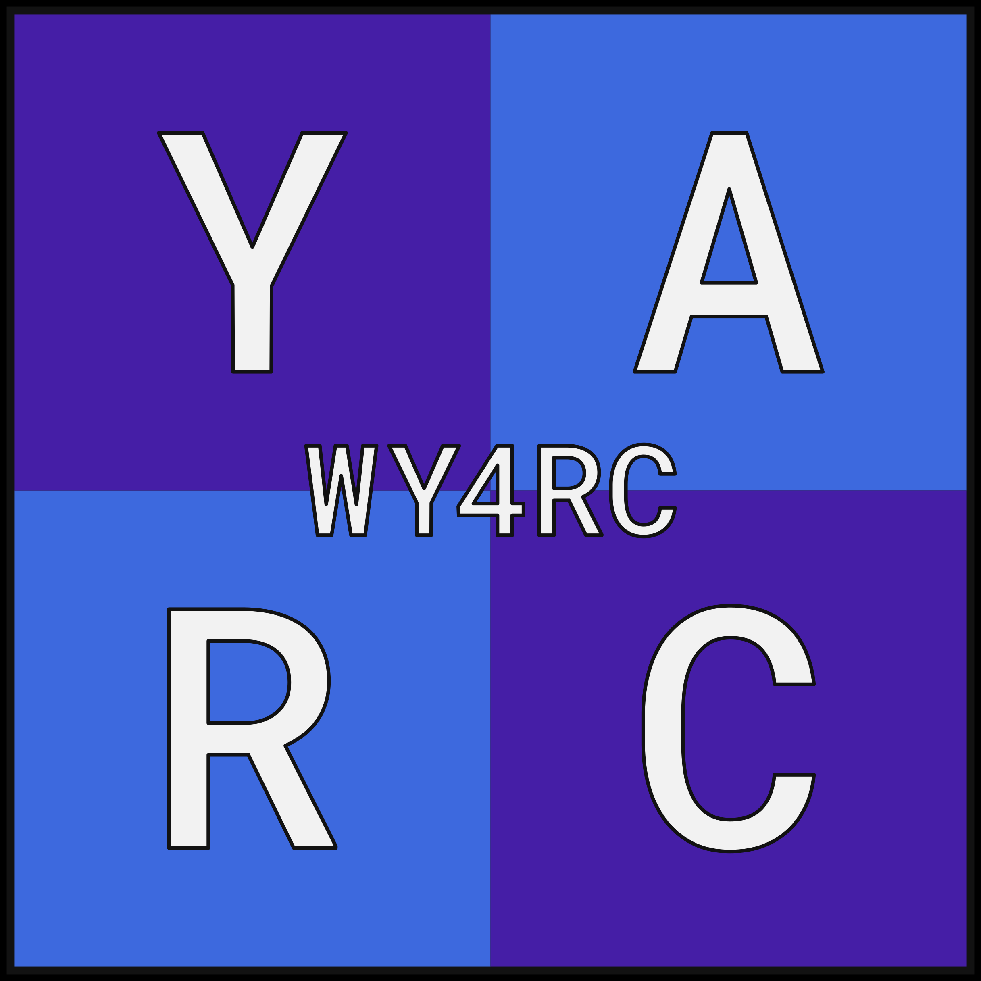

### Promotional

The Large Logo can also include the YARC web address.

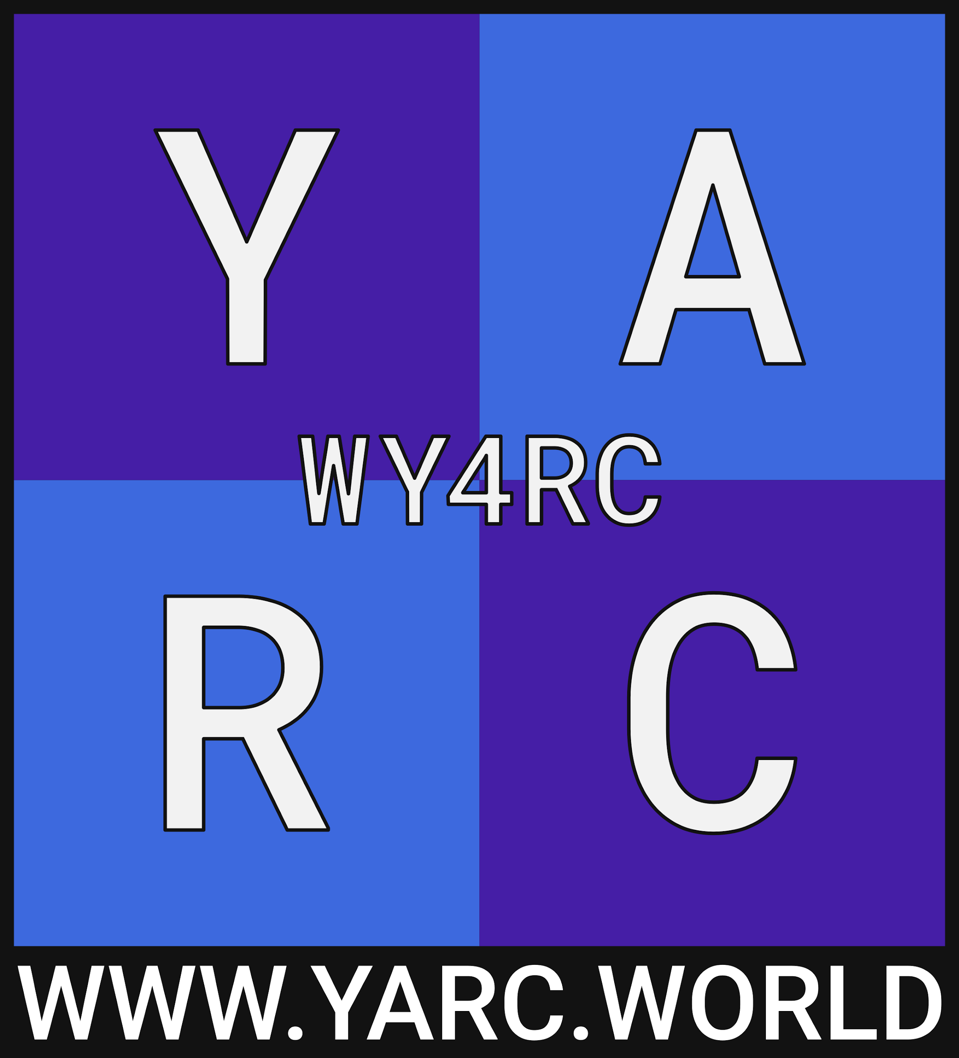

### Small

Use this when the “WY4RC” in the Large Logo is not reasonably readable.

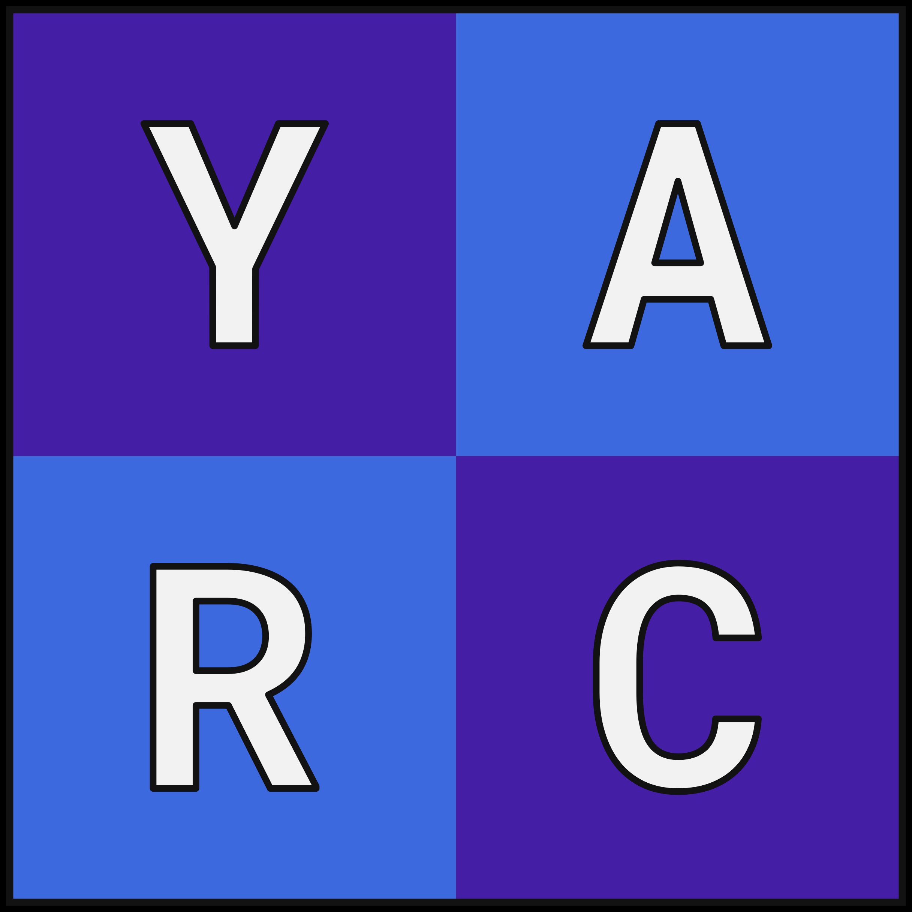

### Monochrome

Use this in simple and monochrome contexts (e.g. print). It should *only* be used in the official white and black colors digitally. In print, use full black and full white.

